MULTI-DISEASE PREDICTION USING MACHINE LEARNING
(An Intelligent Health Assistant for Diabetes, Heart, Liver and Kidney Risk)
Conclusion, Future Scope and References
Department of Computer Science and Engineering, TKR College of Engineering and Technology (Autonomous)
Batch A3 (CSE-A) · Academic year [ACADEMIC YEAR]
Table 1: Project team
S.No. | Student name | Roll number
1 | AJMEERA HARINI | 23K91A0507
2 | BANDI LIKITHA | 23K91A0526
3 | CHINTHAKINDI SWATHI | 23K91A0555
4 | BADROJU SRI HANSIKA | 23K91A0524

Project guide: B. SRUTHI, Faculty Project Guide, Department of CSE
Chapter and section numbers quoted in the text (for example Section 6.6 or Chapter 8) refer to the full project report, 17.Final Document. Figures and tables in this document are numbered from 1.

CHAPTER 9: CONCLUSION

9.1 Summary of the Work
This project set out to replace one-disease-at-a-time screening tools with a single system that estimates the risk of diabetes, heart disease, liver disease and kidney disease from routine clinical values. It built a data generator, a training script that fits and compares Logistic Regression, a Decision Tree, a Random Forest and an RBF Support Vector Machine for each disease on standardised inputs and saves the model with the highest F1, a Flask application that loads the saved models, a FastAPI service with seven routes that reuses the same prediction code, and a React web interface with a prediction form for each disease, a model-comparison page, a dataset page and a not-a-diagnosis notice. Around these, the project added the measurements that the training script does not make: ROC-AUC, confusion matrices, cross-validation, repeated splits, threshold sweeps, permutation importance, a real-data check and API tests.
On the 400-row test sets of the synthetic data, the served models reach accuracy 89.5% (diabetes, SVM), 88.5% (heart disease, Logistic Regression), 91.8% (liver disease, Logistic Regression) and 88.3% (kidney disease, Logistic Regression), close to the 92% ceiling that the 8% label noise allows. Cross-validation and ten random splits show that Logistic Regression is the best model for every disease on every split, including diabetes, where the SVM was shipped on the strength of a single split; Random Forest and the Decision Tree fit the noisy labels and score lower. On real public data the same algorithms reach 76.5% (Pima diabetes), 84.3% (Cleveland heart), 71.8% (ILPD liver) and 98.8% (chronic kidney disease), and the shipped models transfer only partly: for liver disease their accuracy of 54.0% is below the 71.4% majority-class baseline.

9.2 Objectives Revisited
Table 2: Outcome against the six objectives
No. | Objective | Outcome | Evidence
1 | Collect and clean benchmark datasets covering diabetes, heart disease, liver and kidney disorders. | PARTLY | Four datasets of 2,000 rows each exist, but they are synthetic (generated by generate_data.py), not benchmark data.
2 | Handle missing values, outliers and feature scaling through a common preprocessing pipeline. | PARTLY | All inputs pass through one StandardScaler step.
3 | Train and compare Logistic Regression, Decision Tree, Random Forest and Support Vector Machine for each disease. | ACHIEVED | 16 models (4 algorithms x 4 diseases) were trained on the same split with fixed settings and compared.
4 | Select the best model per disease using accuracy, precision, recall and ROC-AUC. | PARTLY | Selection is by F1 on the test set.
5 | Serve the selected models behind a single interface that accepts one patient record. | ACHIEVED | A FastAPI + React application serves the four selected models through 7 API routes; 41 of 41 API checks passed.
6 | Present a per-disease risk indication together with the parameters that drove it. | PARTLY | The risk class and the model's confidence are shown.

Three objectives are met only in part, and the conclusions are written accordingly: the data are synthetic rather than benchmark data, there is no missing-value or outlier handling because the synthetic data contain none, ROC-AUC was not part of model selection, and the application does not show which parameters drove a prediction.

9.3 Key Findings
1. One interface for four diseases works. A single API and web application serve sixteen trained models; a prediction takes about 14 ms at the median on the project machine, and 41 of 41 API checks pass.
2. Synthetic accuracy measures the rule, not the patient. The generator's label rule is linear with 8% flipped labels, so about 92% is the best any model can do; the models reach 88-92% and a linear model is the right family.
3. The simple model is the best model. Logistic Regression has the best F1 on 10 of 10 splits for all four diseases, the highest cross-validated accuracy, and the smallest gap between training and test accuracy.
4. Model selection on one split can be wrong. The shipped diabetes model (SVM, F1 0.8636) is not supported by cross-validation, where Logistic Regression is better.
5. Real data are harder. Accuracy falls to 71.8-84.3% for three of the four diseases, and a model trained on synthetic data can fall below the majority-class baseline on real records.
6. A displayed confidence is not an accuracy. The shown percentage is the probability of the predicted class, and a false positive can be displayed with 99.53%.

9.4 Practical Applications
The system is suitable as a teaching and demonstration aid: it shows how four classical classifiers are trained, compared and served behind one interface, how a model is wrapped in an API and a web form, and how much the numbers depend on the data. With real, validated training data and the additions in Chapter 10 it could become a screening aid in settings with few specialists, helping a health worker decide whom to refer for a confirmatory laboratory test. It is not a diagnostic tool, it has not been validated on patients, and the application says so on every result.

9.5 Known Limitations
The limitations are discussed in full in the Scope and Limitations document; the main ones are:
• The training data are synthetic; the metrics are not clinical performance and cannot be compared with published results on real data.
• Selection of the served model uses the same 400-row test set that reports its score, with fixed settings and no tuning.
• No missing-value or outlier handling, no calibration and no per-prediction explanation; the application's confidence is the probability of the predicted class.
• No range validation: impossible values such as a glucose of 100,000 mg/dL are classified.
• No sign-in, database, audit log or stored history; no pytest suite, usability study, fairness analysis or external validation.

9.6 Concluding Remarks
The project shows that a multi-disease screening pipeline can be built from open-source parts, run on a desktop in seconds, and audited honestly: every number in this report can be regenerated by a script, and the places where the evidence is weak are stated. It follows the base paper [1] in comparing several classifiers by held-out evaluation and in treating interpretability as essential for clinical trust, but it does not reach the paper's rigour (nested cross-validation, real data, SHAP and counterfactual explanations). The next step, described in Chapter 10, is to repeat the evaluation on real patient data with proper validation before anyone relies on the output.
The two figures below summarise the evidence behind the conclusion: the four algorithms side by side on the hold-out split, and the same algorithms on real public data.
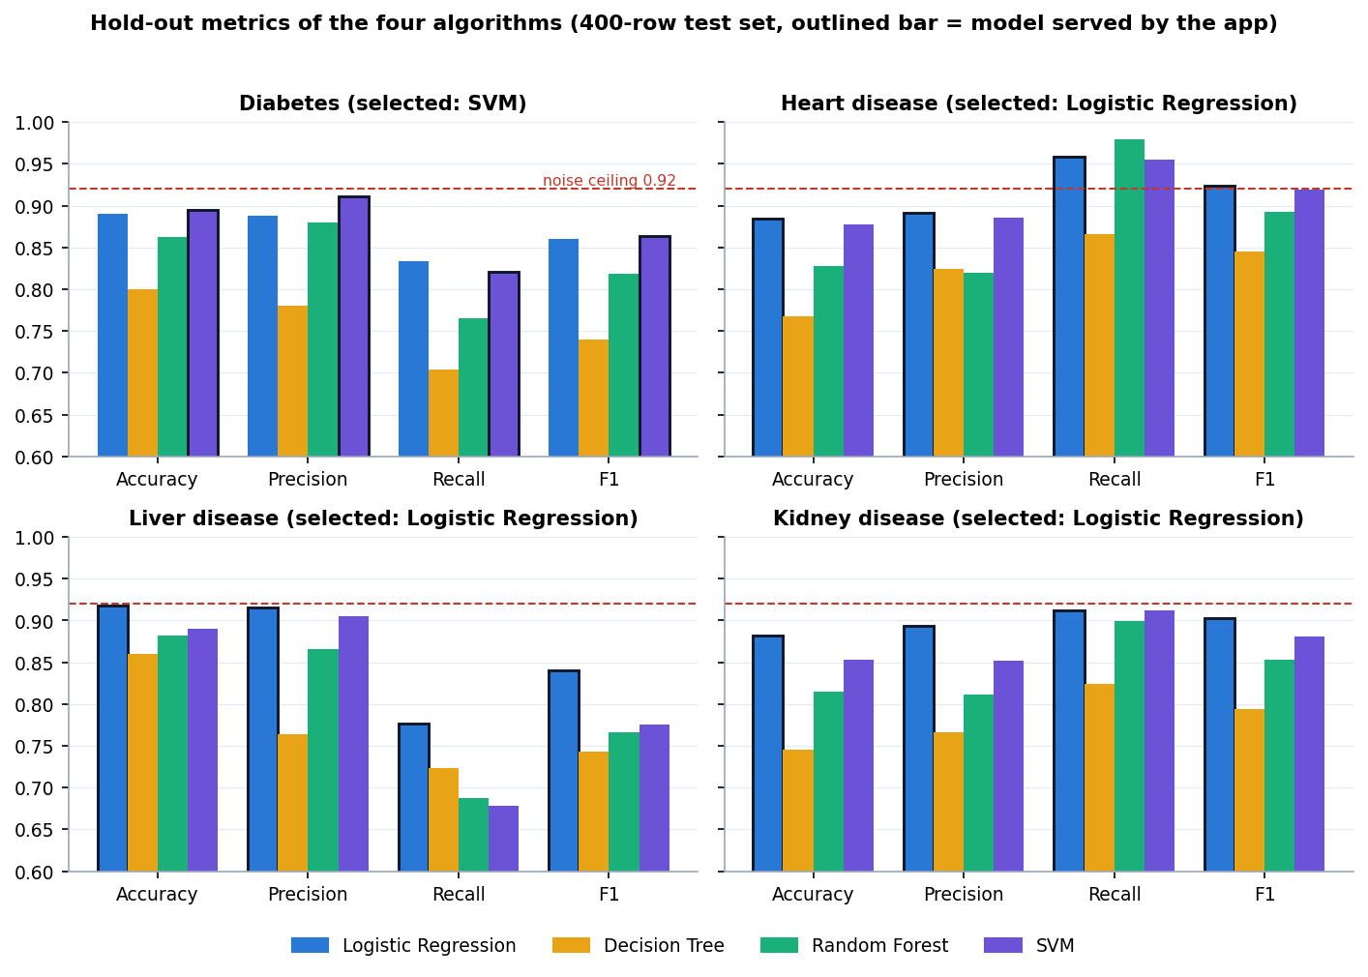
Figure 1: Hold-out metrics of the four algorithms for each disease (seed 42)
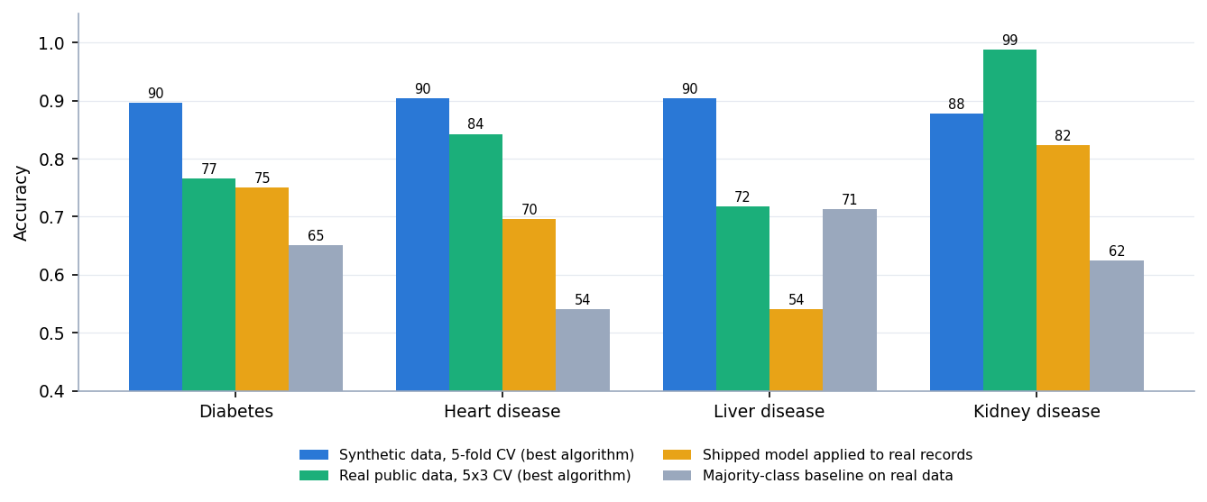
Figure 2: Accuracy on synthetic data, on real public data and of the shipped models on real records

CHAPTER 10: FUTURE SCOPE
The work leaves several directions open. They are ordered by how much they would change the value of the system.
1. Train and validate on real data. Replace the synthetic CSVs by the public benchmark data (Pima, Cleveland, ILPD, chronic kidney disease) or, better, local clinical records, add median or model-based imputation and outlier handling inside the pipeline, and report the real-data results of Section 8.8 as the headline. This addresses the main weakness of the present work.
2. Nested cross-validation and tuning. Follow the base paper: choose hyper-parameters and the algorithm in an inner loop and report an outer-loop estimate, so that model selection no longer uses the reported test set. This would also settle the diabetes choice.
3. Explain every prediction. Add SHAP values and counterfactual "what would change the result" explanations, as in the base paper, and show the driving parameters on the result card; the offline permutation analysis of this report is a starting point.
4. Calibrate and expose the threshold. Apply Platt scaling or isotonic regression on a validation split so that the percentage can be read as a risk, show a reliability curve, and let the user choose the decision threshold for a screening or a confirmatory use.
5. Validate inputs clinically. Reject or flag physiologically impossible values on the server, not only in the form, and show units and reference ranges next to each field.
6. Recommendations and referral guidance. Generate the "healthcare recommendations" promised in the abstract from reviewed clinical rules, with wording approved by a clinician, and link each to a confirmatory test.
7. More conditions and one-record scoring. Add further diseases (for example thyroid, as in the base paper) and score one patient record against all conditions at once, with a combined summary and a missing-value policy for fields that were not measured.
8. Stronger models. Try gradient-boosted trees and calibrated linear models, keep Logistic Regression as the interpretable baseline, and compare with fairness across sex and age groups.
9. Production foundations. Add accounts with roles, an audit log, versioned model storage and a database; containerise the API and the web application; add a pytest suite, frontend tests and a load test.
10. Deployment and scalability. The measured API handled about 415 requests per second on one desktop with four clients, which is ample for a clinic. Beyond that, run several stateless workers behind a reverse proxy; the models are small pickle files.
11. Further research. Study how a screening aid changes referral behaviour in a rural health centre, how explanations affect trust, and whether models trained on one population transfer to another, which the liver result of this report shows to be the critical question.
The first four are the most important: they address the main weakness of this report (synthetic data), the main weakness of the model choice (selection on the reported test set), the main gap against the base paper (explanations) and the main weakness of the output (an uncalibrated confidence).

REFERENCES
[1] M. Z. Alam, R. Rahman, H. M. Sozib, H. Ahmed, A. Hossain, A. A. Sabeena, A. F. Tasnim, F. Ahmed, M. I. Sarkar, and T. I. Erdei, "Enhancing thyroid disease diagnosis with machine learning and counterfactual explainable AI," IEEE Access, vol. 14, pp. 80346-80370, 2026, doi: 10.1109/ACCESS.2026.3663497.
[2] R. Zannat, A. Al Shafi, and A. Muntakim, "Bridging the gap in Bangla healthcare: Machine learning based disease prediction using a symptoms-disease dataset," in Proc. Int. Conf. Elect., Comput. Commun. Eng. (ECCE), Chattogram, Bangladesh, Feb. 2025, doi: 10.1109/ECCE64574.2025.11012950 (arXiv:2601.12068).
[3] J. Al Nahian, A. K. M. Masum, S. Abujar, and M. J. Mia, "Common human diseases prediction using machine learning based on survey data," arXiv:2209.10750, Sep. 2022 (accepted in Bull. Elect. Eng. Informat.).
[4] V. Kamakshamma, G. M. Sumanth, K. R. G. N. K. Reddy, B. Pallavi, and C. S. Varshini, "Multi-disease prediction system using machine learning," in Proc. 1st Int. Conf. Res. Develop. Inf., Commun., Comput. Technol. (ICRDICCT), vol. 2. SCITEPRESS, 2025, pp. 116-127, doi: 10.5220/0013878600004919.
[5] A. Sun and F. Sun, "Prediction of diabetes using supervised classification," J. Emerg. Investigators, Mar. 2024, doi: 10.59720/23-062.
[6] M. A. Islam, M. Z. H. Majumder, and M. A. Hussein, "Chronic kidney disease prediction based on machine learning algorithms," J. Pathol. Inform., vol. 14, Art. no. 100189, 2023, doi: 10.1016/j.jpi.2023.100189.
[7] I. Straw and H. Wu, "Investigating for bias in healthcare algorithms: A sex-stratified analysis of supervised machine learning models in liver disease prediction," BMJ Health Care Inform., vol. 29, no. 1, Art. no. e100457, 2022, doi: 10.1136/bmjhci-2021-100457.
[8] A. Salekin and J. Stankovic, "Detection of chronic kidney disease and selecting important predictive attributes," in Proc. IEEE Int. Conf. Healthcare Informat. (ICHI), 2016, pp. 262-270, doi: 10.1109/ICHI.2016.36.
[9] T. Choudhury, A. Sar, A. Katal, S. Aich, and P. Joshi, "Kidney disease prediction by machine learning techniques," in Machine Learning for Disease Detection, Prediction, and Diagnosis. Singapore: Springer Nature, 2025, pp. 171-190, doi: 10.1007/978-981-96-4241-0_9.
[10] A. Thakur and A. Kumar, "Introduction to deep learning for disease prediction," in Machine Learning for Disease Detection, Prediction, and Diagnosis. Singapore: Springer Nature, 2025, pp. 33-66, doi: 10.1007/978-981-96-4241-0_3.
[11] M. Patil, N. Shinde, R. K. Sharma, S. Kadam, and S. Kashte, "Skin disease prediction using machine learning techniques," in Machine Learning for Disease Detection, Prediction, and Diagnosis. Singapore: Springer Nature, 2025, pp. 225-256, doi: 10.1007/978-981-96-4241-0_12.
[12] J. W. Smith, J. E. Everhart, W. C. Dickson, W. C. Knowler, and R. S. Johannes, "Using the ADAP learning algorithm to forecast the onset of diabetes mellitus," in Proc. Annu. Symp. Comput. Appl. Med. Care, 1988, pp. 261-265.
[13] R. Detrano, A. Janosi, W. Steinbrunn, M. Pfisterer, J. J. Schmid, S. Sandhu, K. H. Guppy, S. Lee, and V. Froelicher, "International application of a new probability algorithm for the diagnosis of coronary artery disease," Amer. J. Cardiol., vol. 64, no. 5, pp. 304-310, Aug. 1989, doi: 10.1016/0002-9149(89)90524-9.
[14] A. Janosi, W. Steinbrunn, M. Pfisterer, and R. Detrano, "Heart Disease," UCI Machine Learning Repository, 1989 (303 instances, 13 features), doi: 10.24432/C52P4X.
[15] L. Rubini, P. Soundarapandian, and P. Eswaran, "Chronic Kidney Disease," UCI Machine Learning Repository, 2015 (400 instances, 24 features), doi: 10.24432/C5G020.
[16] B. Ramana and N. Venkateswarlu, "ILPD (Indian Liver Patient Dataset)," UCI Machine Learning Repository, 2012 (583 instances, 10 features), doi: 10.24432/C5D02C.
[17] F. Pedregosa et al., "Scikit-learn: Machine learning in Python," J. Mach. Learn. Res., vol. 12, pp. 2825-2830, 2011.
[18] L. Breiman, "Random forests," Mach. Learn., vol. 45, no. 1, pp. 5-32, 2001, doi: 10.1023/A:1010933404324.
[19] C. Cortes and V. Vapnik, "Support-vector networks," Mach. Learn., vol. 20, no. 3, pp. 273-297, 1995, doi: 10.1007/BF00994018.
[20] D. W. Hosmer Jr., S. Lemeshow, and R. X. Sturdivant, Applied Logistic Regression. Hoboken, NJ, USA: Wiley, 2013, doi: 10.1002/9781118548387.
[21] S. M. Lundberg and S.-I. Lee, "A unified approach to interpreting model predictions," in Proc. Adv. Neural Inf. Process. Syst. (NIPS), vol. 30, 2017, arXiv:1705.07874.
[22] S. Wachter, B. Mittelstadt, and C. Russell, "Counterfactual explanations without opening the black box: Automated decisions and the GDPR," arXiv:1711.00399, 2017 (Harvard J. Law Technol., 2018).
[23] N. V. Chawla, K. W. Bowyer, L. O. Hall, and W. P. Kegelmeyer, "SMOTE: Synthetic minority over-sampling technique," J. Artif. Intell. Res., vol. 16, pp. 321-357, 2002, doi: 10.1613/jair.953.
[24] S. Varma and R. Simon, "Bias in error estimation when using cross-validation for model selection," BMC Bioinformatics, vol. 7, Art. no. 91, 2006, doi: 10.1186/1471-2105-7-91.
[25] D. Chicco and G. Jurman, "The advantages of the Matthews correlation coefficient (MCC) over F1 score and accuracy in binary classification evaluation," BMC Genomics, vol. 21, Art. no. 6, 2020, doi: 10.1186/s12864-019-6413-7.
[26] T. Saito and M. Rehmsmeier, "The precision-recall plot is more informative than the ROC plot when evaluating binary classifiers on imbalanced datasets," PLoS ONE, vol. 10, no. 3, Art. no. e0118432, 2015, doi: 10.1371/journal.pone.0118432.

